Summary of “The Economic, Climate, Fiscal, Power, and Demographic Impact of a National
Fee-and-Dividend Carbon Tax” By REMI and Synapse
Summary by Danny Richter, Ph.D.
About the study:
Citizens' Climate Education Corporation (CCEC) and Citizens' Climate Lobby (CCL) contracted a third party, Regional Economic Modeling, Inc. (REMI) to do a nation-wide macroeconomic study on the impact of its Fee and Dividend (F&D) policy. The policy modeled is not a perfect representation of F&D (most obviously, F&D begins at $15 per ton whereas the study began at $10 per ton), but it is quite close, and accounts for the impact F&D's border tariff adjustment would have on the US economy. REMI used three models to do the study: (1) The Regional Energy Deployment System (ReEDS) built by the National Renewable Energy Laboratory and run by Synapse Energy Economics; (2) the Carbon Analysis Tool (CAT); an enhancement of the open-source CTAM model and populated by data from the US Energy Information Administration (EIA); and (3) REMI PI+, a proprietary dynamic model of subnational units of the United States’ economy whose methodology and equations are peer-reviewed and available to the public. Output included impacts on 160 industries, nationally and regionally for the 9 “U.S. Census” regions commonly grouped together in a number of federal data sources and in the energy market forecasts from the EIA.
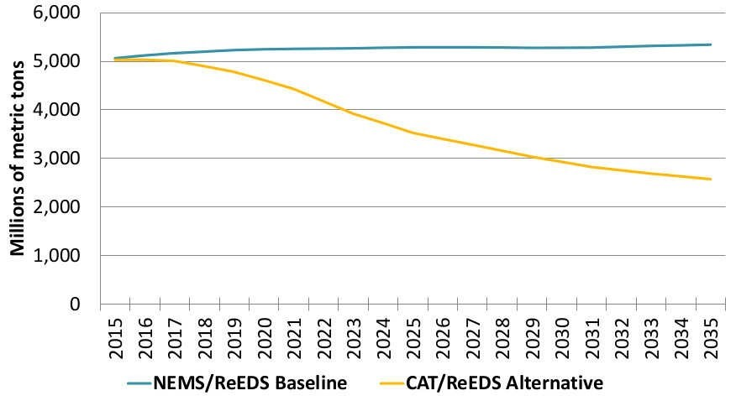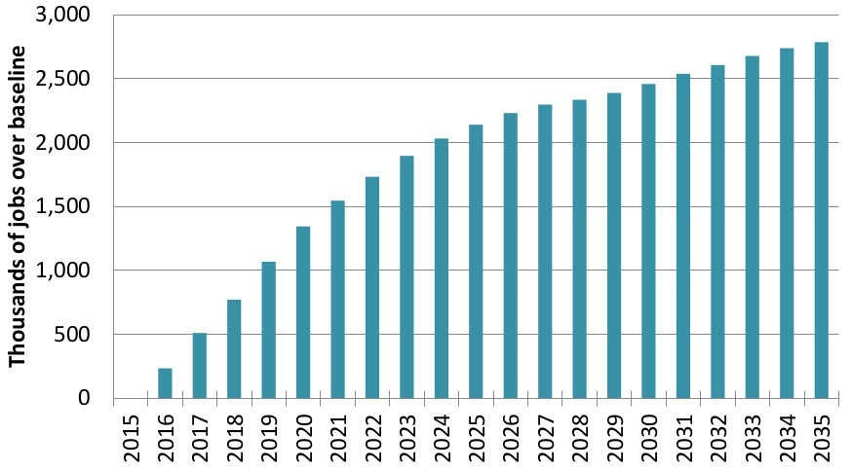
Figure 1: U.S. CO2 emissions under F&D (yellow) and Figure 2: Thousands of jobs created by F&D relative to without a carbon tax (blue). F&D reduces US emissions to the case without a carbon tax. Over a million jobs created 69% of 1990 levels by 2025, and to 50% by 2035. within 4 years, over 2 million within 9 years.
Model results were able to estimate the effects of the policy on GDP, personal income, employment, prices, carbon dioxide emissions, mortality due to NOx and SOx emissions, revenues, monthly dividend amount, energy generation capacity by technology, energy generation by type, investment in power, population, and economic migration on both a regional and national level. Income and employment figures for each of 160 industry categories considered are included. These 160 industries encompass the entire economy.
The results are all relative to a baseline case where there is no carbon tax (modeled by using the exact same set-up, with a $0/ton value for the carbon tax). In other words, all three models were run two times. Both times, the set-up was identical except for one thing: the price of carbon was either $0 from 2016-2035 (the baseline), or was $10 per ton in 2016 and increased by $10 every year after that (F&D).
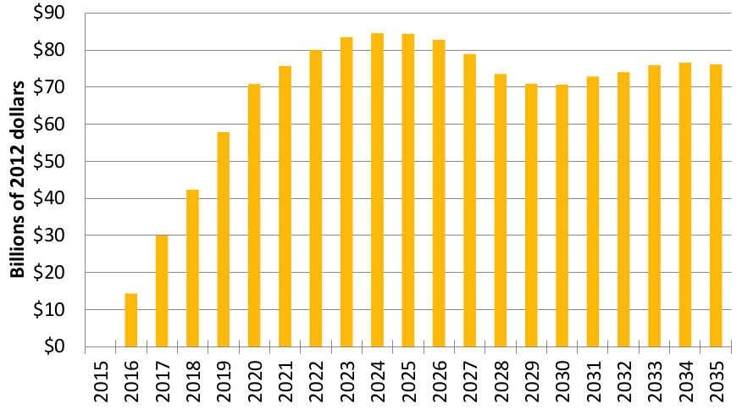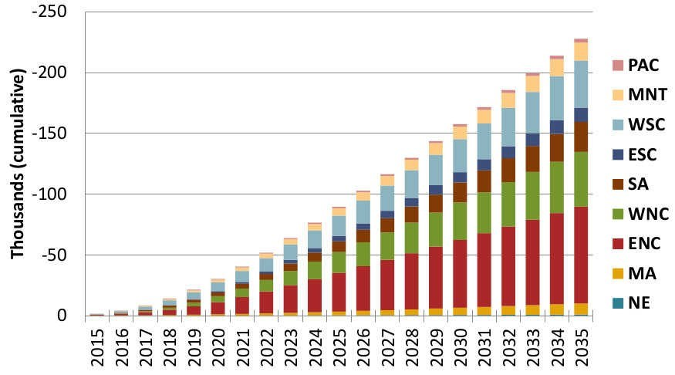
Figure 3: Cumulative lives saved from avoided Figure 4: Annual additional GDP due to Fee and emissions by region under F&D. Region ENC, including Dividend relative to no carbon tax. The numbers are Ohio, Indiana, Michigan, Illinois, and Wisconsin, has the positive due to a net increase in jobs and more consumer most lives saved. 227,000 American lives would be spending from the dividend. Over the 20 years of the saved in 20 years under F&D. study, GDP is $1.375 trillion higher than without F&D.
Why should we trust REMI?
CCL hired REMI because we are committed to quality data free of ideological taint that you might get from some think tanks. As its name suggests, REMI models regional economics. It does this well. Dr. George Treyz founded REMI in 1980, after working as an academic with Nobel Prize-winner Lawrence Klein and other pioneers in the field of econometric modeling. REMI's modeling products grew from Dr. Treyz's work on one of the first regional macroeconomic models ever created: the Massachusetts Economic Policy Analysis (MEPA) model. Close links to the upper echelons of academia have persisted throughout REMI's 3+ decades of experience, resulting in several academic publications in journals such as the American Economic Review, the Review of Economics and Statistics, and the Journal of Regional Science.
This experience and expertise is why private and public entities from all across the political spectrum have entrusted REMI to do their analyses, and paid them well for that expertise. These former clients include, but are not limited to: the American Gas Association (AGA), the Nuclear Energy Institute (NEI), the National Federation of Independent Business
(NFIB), the National Education Association (NEA), the International Brotherhood of Teamsters, Booz Allen Hamilton, EY (formerly Ernst and Young), PWC (formerly Price Waterhouse Coopers), and ICF International. Like CCL and CCEC, REMI is truly nonpartisan.
In that same spirit, CCL and CCEC did not attempt to influence the outcome of the report in any way. In fact, we were excited when we saw that not all the results were positive for every region, because that speaks to the integrity of the analysis. Our first priority is a livable world, and we can't get there without an honest and clear-eyed view of the facts.
Study Highlights:
- CO2 emissions decline 33% after only 10 years, and 52% after 20 years relative to the baseline, $0/ton of CO2 case (Figure 1).
- National employment increases by 2.1 million jobs after 10 years, and 2.8 million after 20 years. This is more than a 1% increase in total US employment we don't get without a carbon tax (Figure 2)!
- 13,000 lives are saved annually after 10 years, with a cumulative 227,000 American lives saved over 20 years (Figure 3).
- $70-$85 billion increase in GDP from 2020 on, with a cumulative increase in national GDP due to F&D of $1.375 trillion (Figure 4).
- Size of monthly dividend for a family of 4 with two adults in 2025 = $288, and in 2035
= $396. Annually, this is $3,456 per family of 4 in 2025 ($1152 per capita--children get ½ dividend) (Figure 5).
- Electricity prices peak in 2026, then start to decrease.
- Real incomes increase by more than $500 per person in 2025. This increase accounts for cost of living increases (Figure 6).
- Maximum cost-of-living increase by 2035 is 1.7-2.5%, depending on region (Figure 7).
- Electricity generation from coal is phased-out by 2025.
- Biggest employment gains in healthcare, retail, and other services (excluding public administration). This is because people have more money in their pockets to spend, and these industries are labor-intensive, responding to increased consumer spending by creating more jobs.
- Regional Gross Product is steady or rising in all 9 regions.
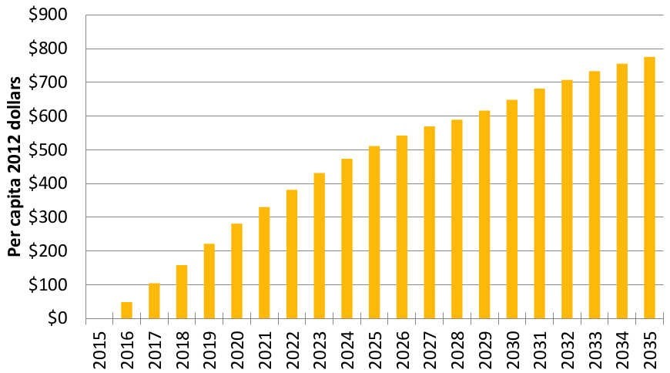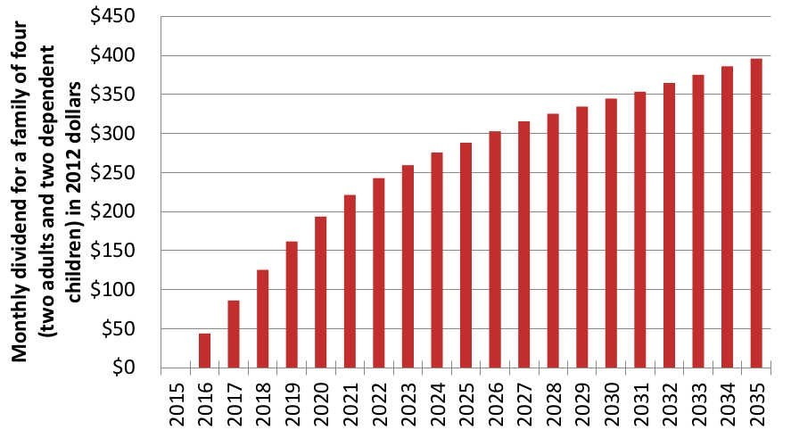
Figure 5: Average monthly dividend for a family of four. Figure 6: U.S. income per capita, after accounting for Each adult gets two full shares, and each child 1 cost-of-living increases. This means that even
half-shares up to two children for a maximum of 3 full accounting for the increased cost of living, the average shares per household. American is wealthier every single year of the policy.
Why Haven't Previous Studies Found Such Positive Impacts?
The majority of previous reports considering a carbon tax have not modeled a completely revenue-neutral carbon tax, do not envision a policy with such an aggressive rate of increase, do not have the same detail as REMI can provide, do not consider a 100% dividend, and do not report health benefits. Where revenue-neutrality was modeled, a “double-dividend” was often discovered in which carbon emissions were reduced and economic output grew. As these previous studies have highlighted, including a May 2013 study by the Congressional Budget Office (CBO), a carbon tax without revenue- recycling is a completely different policy from a carbon tax that does recycle revenue. The two policies, revenue-neutral carbon tax and a carbon tax without revenue returned, should not be confused in terms of their effect on the economy.
Failing to consider such a rapid rate of increase in the carbon tax has prevented previous studies from realizing the magnitude of emissions reductions and scale of economic benefit reported in this study. Often, this was because such rates of increase were not considered politically feasible. Most other models, run by academics or think tanks, do not have the detail provided by REMI. Over the past 3 decades, REMI's regional modeling techniques have been refined, detail has been added, and functionality improved. Three decades of such work and refinement in the private sector are what have given it an unmatched level of detail and reliability difficult to replicate.
Despite these differences in conception, the results of REMI's work are largely consistent with previous studies in terms a benefit to the economy, industry effects, and emissions reductions. For example, the May 2013 CBO study also stated that a well-designed carbon tax could increase economic output and found a hypothetical $20 per ton carbon tax scenario would result in an 8% reduction in emissions at the national level. If held at that level, REMI's model setup would have found comparable results.
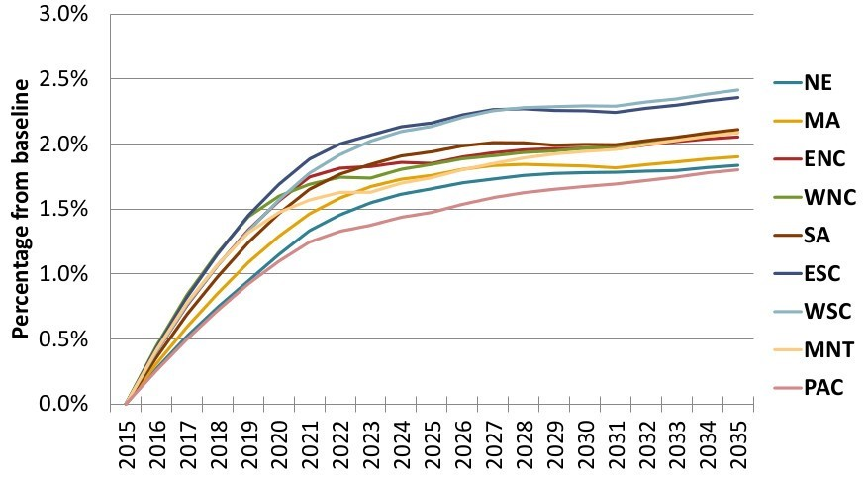
Figure 7: Cost of living increases by region. The lowest cost of living increase is around 1.7%, and the highest is 2.5% in 2035. The total increase over 20 years is thus about equal to 1 year of average inflation.
Interpreting the Results: Take-home points
The biggest take-home from this study is that there is no economic argument against Fee and Dividend. It creates jobs, grows the economy, saves lives, and makes Americans richer. It does this while also reducing CO2 emissions to 31% below 1990 levels by 2025, and to 50% below 1990 levels by 2035.
F&D therefore sets the new standard for climate and economic policy. Other policies must now compare their climate and economic impact against F&D. To be against doing anything is to be against jobs, against a larger economy, and against saving American lives. We know of no politician who wants to be against these things, and so we hope that this study will clear the way to rapid passage of F&D.
Revision 6: August 1, 2014

